Study the following words for spelling test.
Test is due on Wednesday 5/22/19
The picture | The meaning | The word
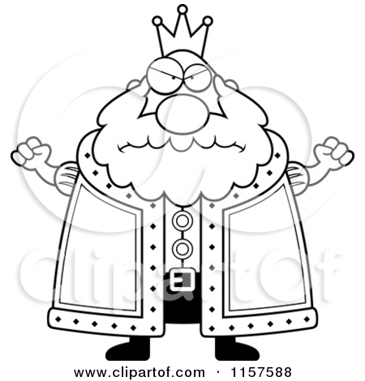 | king | مَلِكٌ
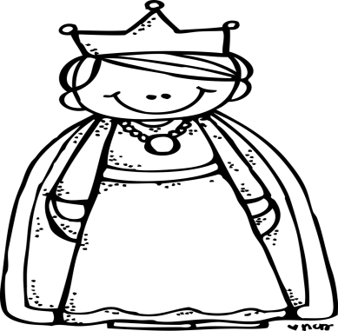 | queen | مَلِكَةٌ
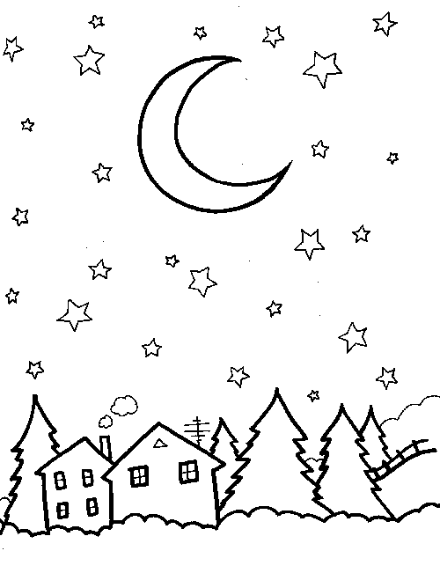 | night | لَيْلٌ

Draw a picture | Copy the word | The word
 |  | مَلِكٌ
 |  | مَلِكَةٌ
 |  | لَيْلٌ

First, write the word three times. Read it aloud each time you write it. Then color the picture.
1.________________ لَيْلٌ
_____________ . 3 _____________ .2
1._________________ مَلِكَةٌ 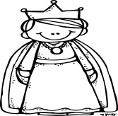
_____________ . 3 _____________ .2
1._________________ مَلِكٌ
_____________ . 3 _____________ .2

Break down:
___-___-___ لَيْلٌ
مَلِكٌ ___-___-___
___-___-___-___ مَلِكَةٌ

What is the meaning of the following words in Arabic? 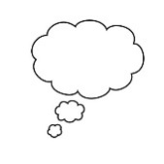
Write the words in Arabic and draw pictures.
- queen
_________________________
- king
_______________________
- night
_____________________

